MA374-LAB4

Nikhil Agarwal

Roll:11012323

1.

a.

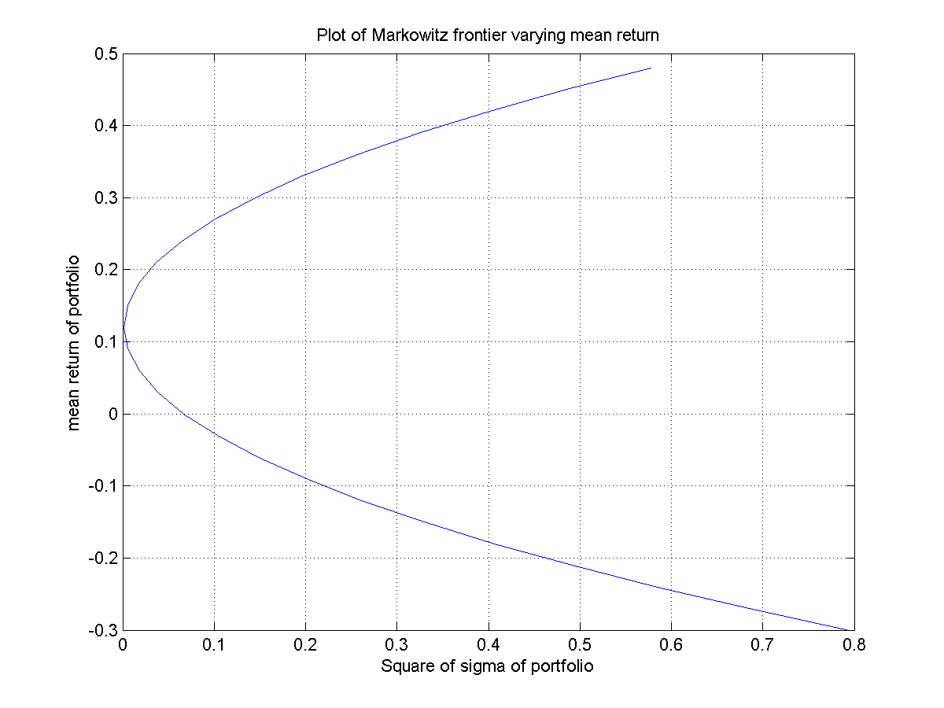

b.

|  |  |  |  |  |
| --- | --- | --- | --- | --- |
| Mean Return of portfolio | Minimum risk of portfolio | Weight1 | Weight2 | Weight3 |
| -0.300000 | 0.794349 | 6.844037 | -2.155963 | -3.688073 |
| -0.270000 | 0.685377 | 6.414679 | -1.985321 | -3.429358 |
| -0.240000 | 0.584457 | 5.985321 | -1.814679 | -3.170642 |
| -0.210000 | 0.491589 | 5.555963 | -1.644037 | -2.911927 |
| -0.180000 | 0.406773 | 5.126606 | -1.473394 | -2.653211 |
| -0.150000 | 0.330009 | 4.697248 | -1.302752 | -2.394495 |
| -0.120000 | 0.261298 | 4.267890 | -1.132110 | -2.135780 |
| -0.090000 | 0.200638 | 3.838532 | -0.961468 | -1.877064 |
| -0.060000 | 0.148031 | 3.409174 | -0.790826 | -1.618349 |
| -0.030000 | 0.103476 | 2.979817 | -0.620183 | -1.359633 |

c.

For 15 % risk maximum return is 0.052447 and the corresponding weights are: 1.799843, -0.151220, -0.648624.

For 15 % risk minimum return is 0.189555 and the corresponding weights are: -0.162436, 0.628660, 0.533775.

d.

For 18% return weights of minimum risk portfolio are -0.025688, 0.574312, 0.451376.

e.

Assuming risk free return of 10% weights of minimum risk portfolio are 0.593750, 0.328125, 0.078125.

The Capital market line is given by:

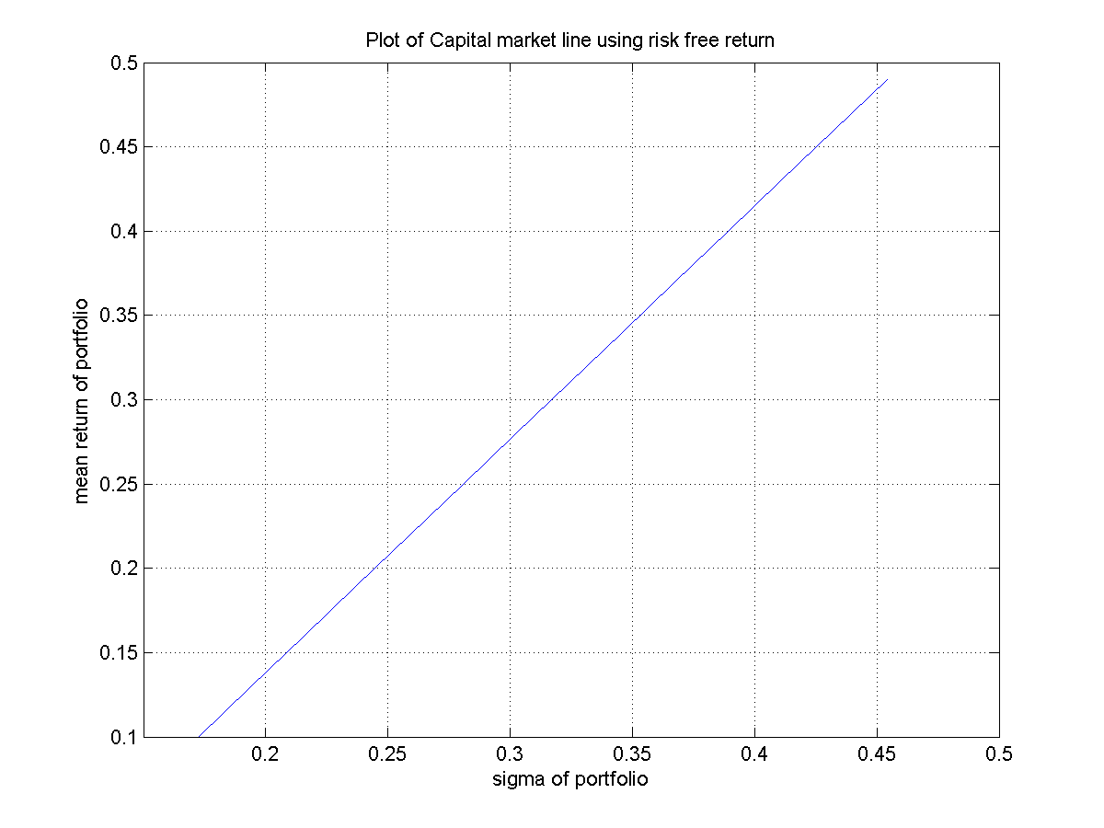

f.

For the risk of 10% weight of risky and risk free assets are 1.968067, -0.968067 respectively.

For the risk of 25% weight of risky and risk free assets are 4.920166, -3.920166 respectively.

2.

a. The plot of Markowitz frontier: 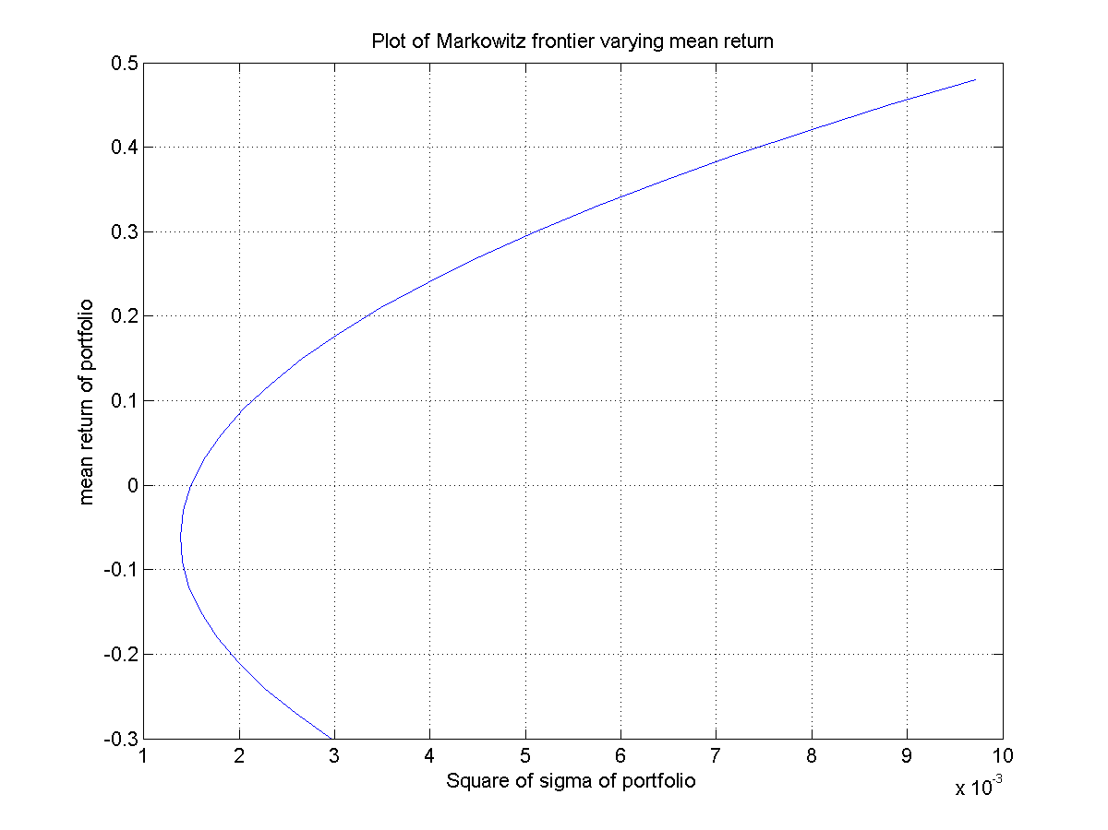

b.

The weights of all the 10 stocks in the portfolio are : 0.416152, 0.032472, 0.527615, -0.185373, -0.978389, -0.034939, -0.402606, -0.012072, 0.943120, 0.694021 respectively.

c. The plot of Capital Market line: 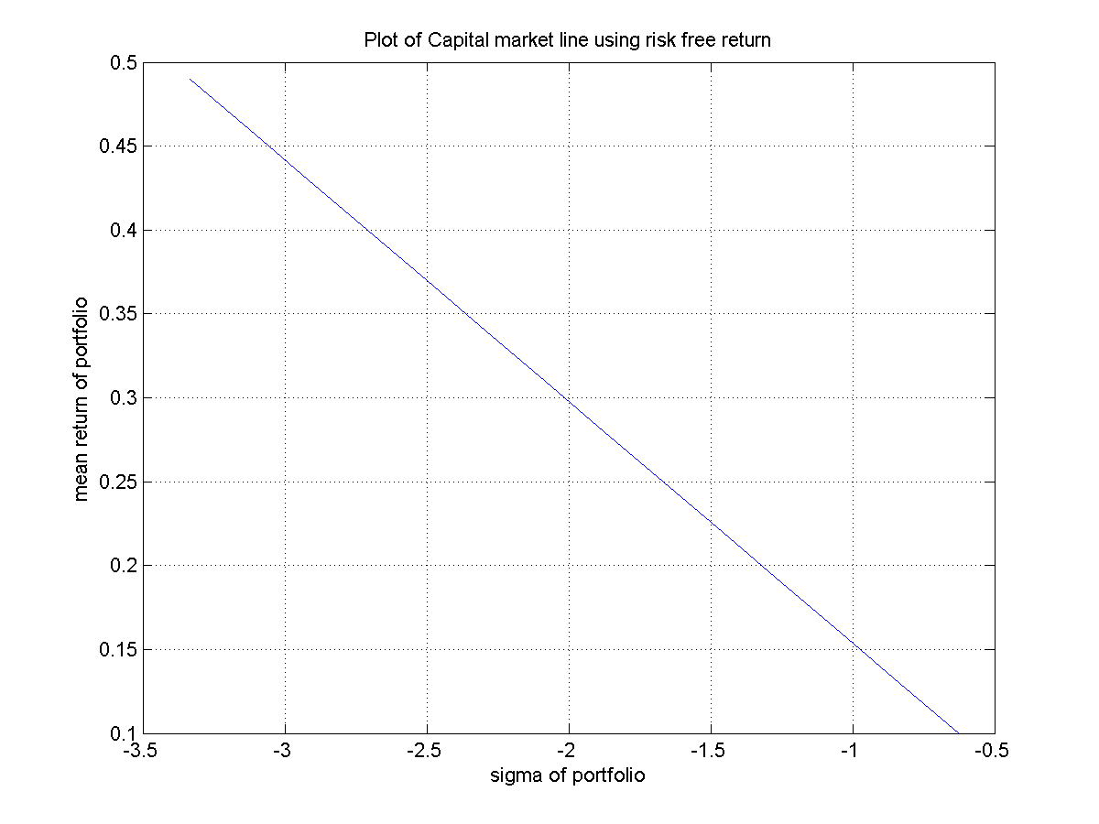

d. Plot of security market for asset 1 is: 